Seller and Inventory Management System

Project Title : Seller and Inventory management Database System
Student Name : Yakesh J
Register Number : C4S38024
Department : B.Sc Artificial Intelligence
Course : Artificial intelligence (AI)
Academic Year : 2024 – 2027

1. Create Seller Table
CREATE TABLE Seller (
seller_id INT PRIMARY KEY AUTO_INCREMENT,
seller_name VARCHAR(100) NOT NULL,
email VARCHAR(100),
phone VARCHAR(15),
address VARCHAR(200)
);
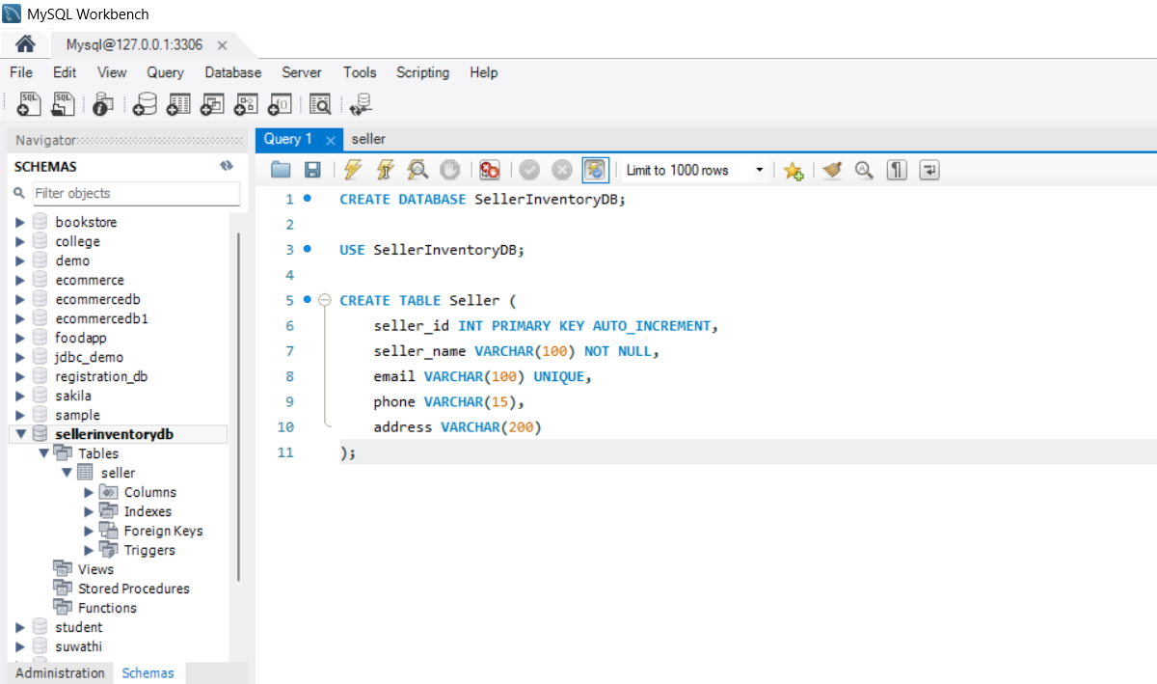

2. Create Product Table
CREATE TABLE Product (
product_id INT PRIMARY KEY AUTO_INCREMENT,
product_name VARCHAR(100) NOT NULL,
category VARCHAR(50),
price DECIMAL(10,2)
);

3. Create Inventory Table and Establish Relationships
CREATE TABLE Inventory (
inventory_id INT PRIMARY KEY AUTO_INCREMENT,
seller_id INT,
product_id INT,
quantity INT DEFAULT 0,
status VARCHAR(20),

FOREIGN KEY (seller_id) REFERENCES Seller(seller_id),
FOREIGN KEY (product_id) REFERENCES Product(product_id)
);
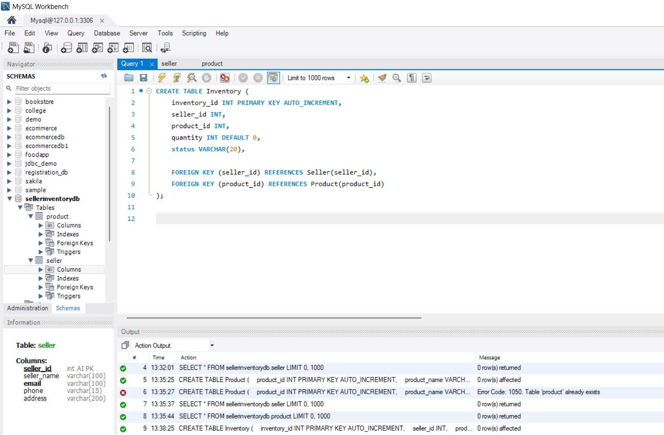

4. Insert Seller and Product Information
INSERT INTO Seller (seller_name, email, phone, address)
VALUES
('ABC Traders', 'abc@gmail.com', '9876543210', 'Madurai'),
('XYZ Stores', 'xyz@gmail.com', '9876501234', 'Chennai');

INSERT INTO Product (product_name, category, price)
VALUES
('Laptop', 'Electronics', 55000),
('Keyboard', 'Electronics', 1500),
('Chair', 'Furniture', 7000);
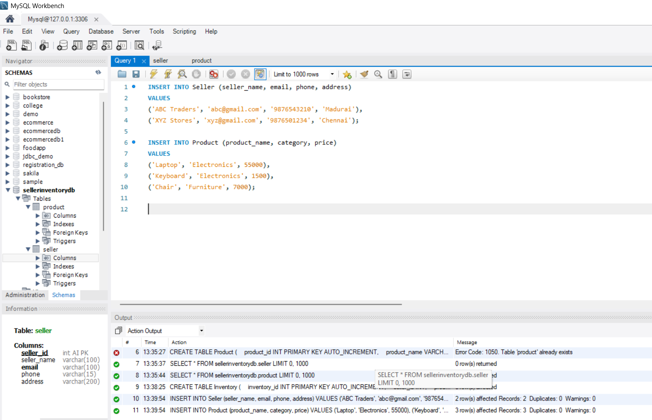
5. Add Inventory Information
INSERT INTO Inventory (seller_id, product_id, quantity, status)
VALUES
(1, 1, 10, 'Available'),
(1, 2, 0, 'Unavailable'),
(2, 3, 5, 'Available');
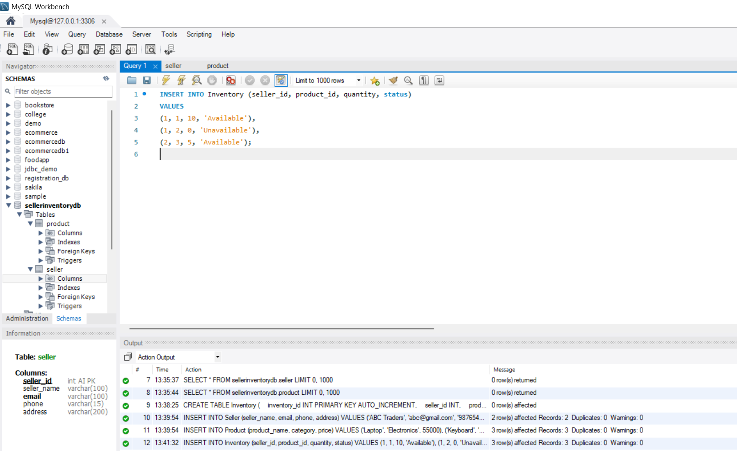
6. Display Seller Product Information
SELECT
s.seller_name,
p.product_name,
p.price,
i.quantity,
i.status
FROM Inventory i
JOIN Seller s ON i.seller_id = s.seller_id
JOIN Product p ON i.product_id = p.product_id;
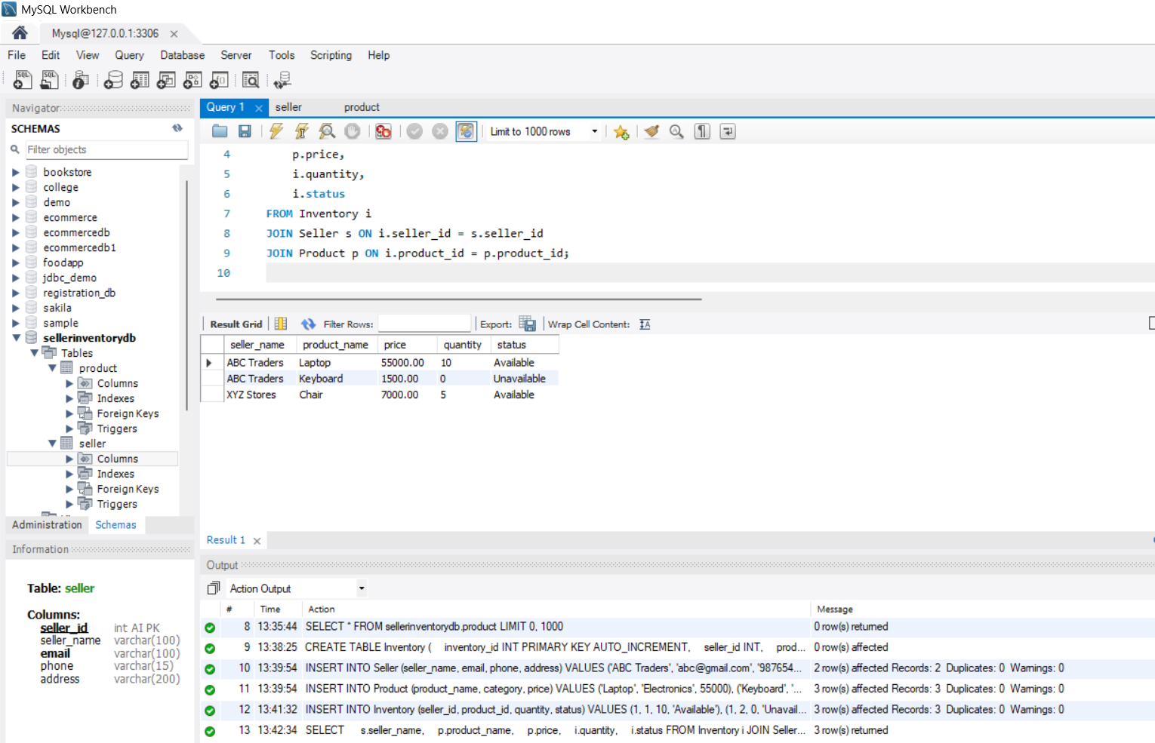

7. Track Available Products
SELECT *
FROM Inventory
WHERE status = 'Available';
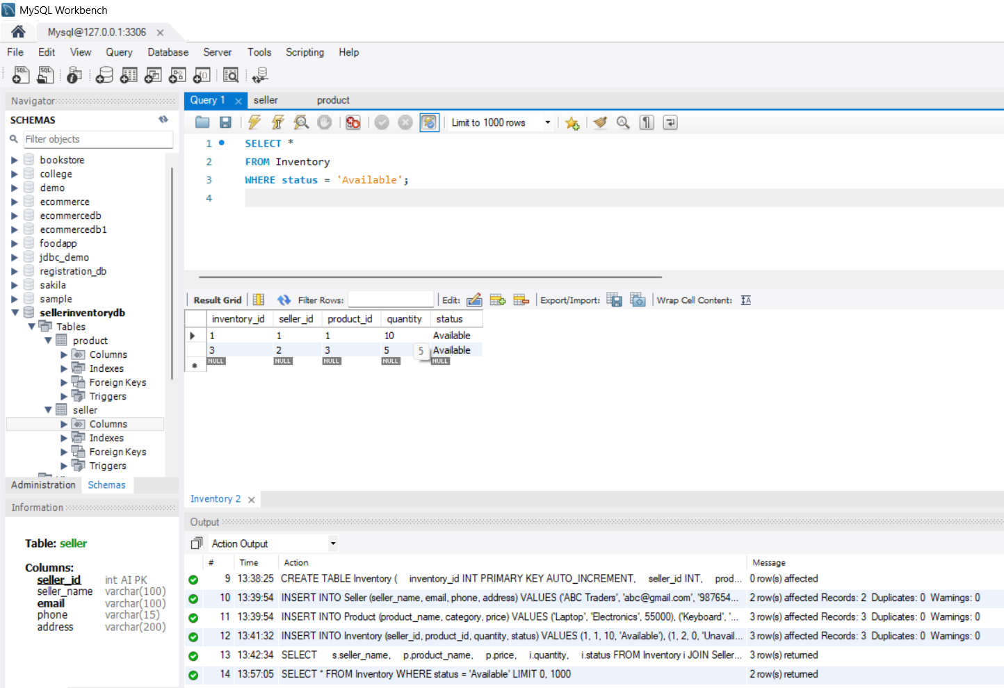
8. Track Unavailable Products
SELECT *
FROM Inventory
WHERE status = 'Unavailable';
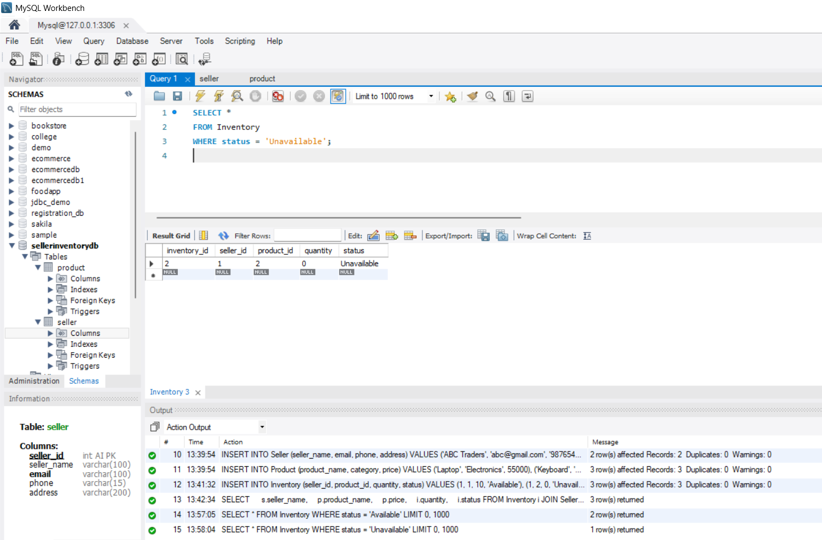

9. Generate Inventory Status Report
SELECT
p.product_name,
SUM(i.quantity) AS total_quantity,
CASE
WHEN SUM(i.quantity) > 0 THEN 'Available'
ELSE 'Unavailable'
END AS status
FROM Inventory i
JOIN Product p
ON i.product_id = p.product_id
GROUP BY p.product_id, p.product_name;
